st20274654 CIS6008 WRIT1



Acknowledgement

I would like to thank my lecturer Mr. Induranga Silva for guiding me throughout the assignment. I would also like to thank my parents and colleagues who helped in various ways to make this assignment success

Introduction

The growth of data analytics and Geographic Information Systems(GIS) has revolutionized the way organizations engage in strategic planning and decision-making. In Sri Lanka’s Higher Education Sector, these modern technologies offer powerful means to detect inefficiencies, assess institutional performance and support evidence based policy formulations. This report emphasizes the application of booth statistical and spatial analytical methods to generate valuable insights that assist the Ministry of Higher Education(MOHE) in enhancing service delivery, improving accessibility and promoting the fair allocation of educational resources throughout the country.

This study uses a variety of spatial and non-spatial datasets –including CV files, shape files, raster layers and official documents to carry out tasks such as statistical modeling, map creation, spatial analysis and geospatial database development. Tools like R, R-Studio, QGIS, PostgreSQL and Google Earth help analyze university rankings, school and university distribution, MOHE’s location and potential sites for a new Space Science Research Center. Each task is backed by data analysis and visual outputs to support informed decision-making.

The main aim of this report is to provide a clear, data-driven overview of Sri Lanka’s higher education landscape and suggest practical recommendations for its advancement. By combining statistical method with spatial analysis, the report supports MOHE in developing efficient, transparent policies and highlights how location based insights can improve both educational outcomes and national development.

List of abbreviation
- Task(A)

  - IN: Name of the university or institution
  - IT: Type of institution(Public/Private)
  - SE: Total number of enrolled students
  - FS: Average faculty salary in USD
  - RF: Research funding in million USD
  - GR: Graduation success rate in percentage
  - SFR: Ratio of students to faculty members
  - TF: Annual tuition fees in USD
  - ER: Graduate employment rate in percentage
  - URS: Overall university ranking score

- Task(D)

  - UOC: University of Colombo
  - UOP: University of Peradeniya
  - UOSJ: University of Sri Jayewardenepura
  - UOK: University of Kelaniya
  - UOM: University of Moratuwa
  - UOJ: University of Jaffna
  - UOR: University of Ruhuna
  - EU: Eastern University
  - RU: Rajarata University
  - SU: Sabaragamuwa University
  - WU: Wayamba University
  - UOVAPA: University of Visual & performing Arts
  - OUOSL: Open University of Sri Lanka
  - SEUOSL: South Eastern University of Sri Lanka
  - UWU: Uwa Welassa University
  - SLIIT: Sri Lanka Institute of Information Technology
  - GSJKDU: General Sir John Kotelawala Defense University

  - BAPU: Buddhist and Pali University

Task(A)

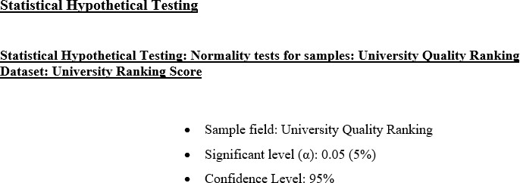

(*) Whether or not University Ranking Score values across higher education institutions are normally distributed?
H0: University Ranking Score values across higher education institutions are normally distributed.
H1: University Ranking Score values across higher education institutions are not normally distributed.

Anderson Darling Test

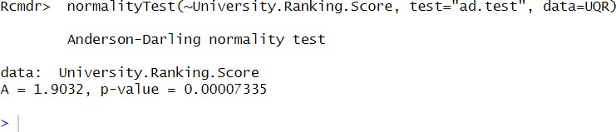

Decision: p-value=0.00007335< α=0.05=>Reject H0 at 5% significant level

Lillie Test

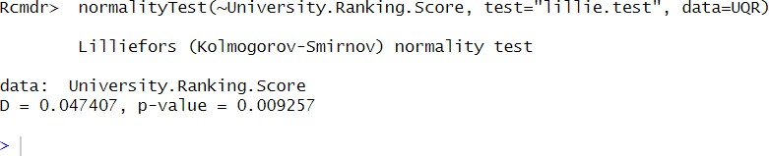

Decision: p-value=0.009257< α=0.05=>Reject H0 at 5% significant level

Shapiro Test

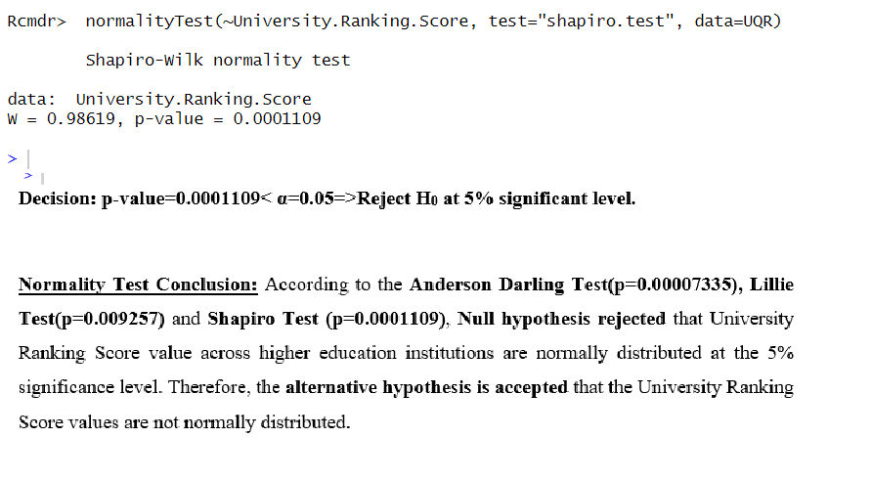

Graphical Analysis of University ranking Score

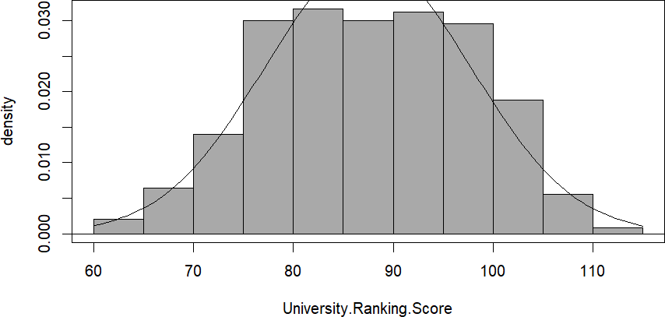

As seen on (Figure 4) there is a slight right skewedness of the bell curve identifiable. Although it appears roughly symmetrical, the peak is modestly shifted to the left, with a slightly longer tail on the right side.
This visual pattern, along with the results from normality tests, indicates that the university Ranking score is not normally distributed at the 5% significance level. Therefore, the null hypothesis is rejected and the alternative hypothesis is accepted.

Statistical Hypothetical Testing: Normality Test for sample: Student Enrollment Dataset: Student enrollment
- Sample field: Student Enrollment
- Significant Level (α): 0.05 (5%)
- Confidence Level: 95%

(*) Whether or not Student Enrollment values across higher education institutions are normally distributed?
H0: Student Enrollment values across higher education institutions are normally

distributed.
H1: Student Enrollment values across higher education institutions are not normally distributed.

Anderson Darling Test

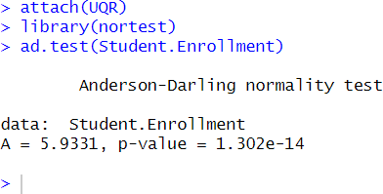

Decision: p-value=1.302e-14< α=0.05=>RejectH0 at 5% significant level

Lillie Test

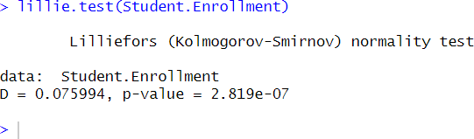

Decision: p-value=2.819e-07< α=0.05=>Reject H0 at 5% significant level

Shapiro Test

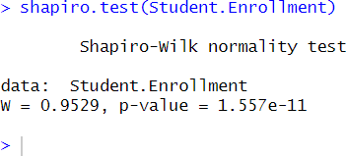

Decision: p-value=1.557e-11< α=0.05=>Reject H0 at 5% significant level

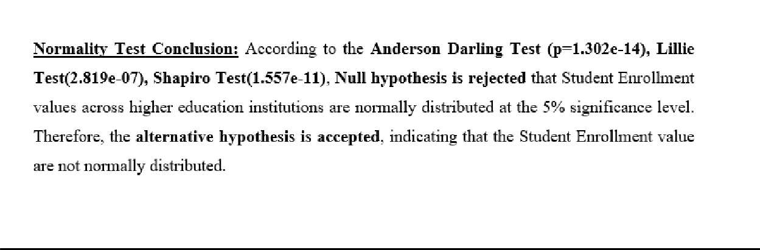

Graphical Analysis of Student Enrollment

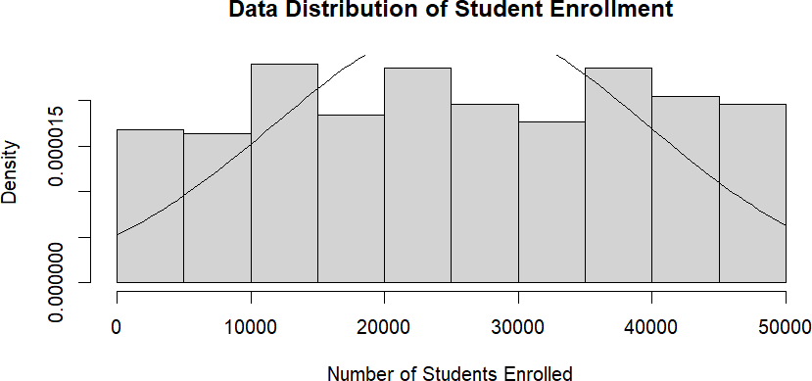

As seen on (Figure 8) there is a fairly and irregular, without a clear bell shaped curve. This histogram shows noticeable deviations from normality, with a peak and no central symmetry.
This visual pattern along with the results from student enrollment normality tests, indicates that student enrollment is not normally distributed at the 5% significance level. Therefore, the null hypothesis is rejected and the alternative is accepted.

Statistical Hypothetical Testing: Normality Test for sample: Faculty Salary Dataset: Faculty Salary
- Sample field: Faculty Salary
- Significant Level (α):0.05 (5%)
- Confidence Level: 95%

(*) Whether or not Faculty Salary values across higher education institutions are normally distributed?

H0: Faculty Salary values across higher education institutions are normally Distributed.
H1: Faculty Salary value across higher education institutions are not normally distributed.

Anderson Darling Test
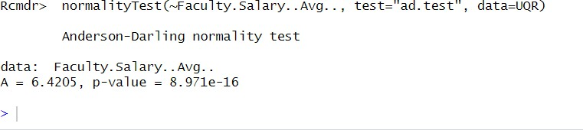

Decision: p-value=8.971e-16< α=0.05=>Reject H0 at 5% significant level

Lillie Test
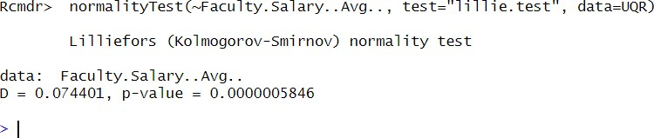

Decision: p-value=0.0000005846< α=0.05=>Reject H0 at 5% significant level

Shapiro Test

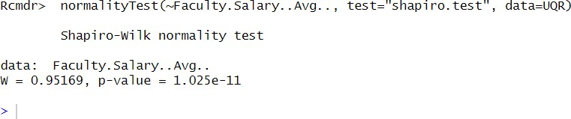

Decision: p-value=1.025e-11< α=0.05=>Reject H0 at 5% significant level

Normality Test Conclusion: According to the Anderson Darling Test (p=8.971e-16), Lillie Test(p=0.0000005846) and Shapiro Test(p=1.025e-11), Null hypothesis is rejected that faculty salary values across higher education institutions are normally distributed at 5% significance level.
Therefore, the alternative hypothesis is accepted, indicating that the faculty salary values are not normally distributed.

Graphical Analysis of Faculty Salary

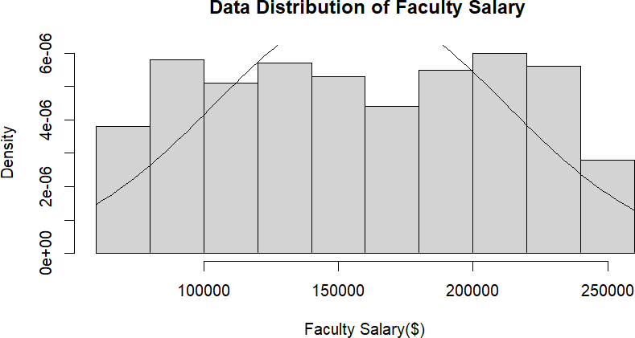

As seen on (Figure 12), the histogram of faculty salary shows a relatively uniform and slightly right skewed distribution, deviating from the ideal bell curve. Therefore, the faculty salary values across higher education institutions are not normally distributed at 5% significance level.

Statistical Hypothetical Testing: Normality Test for sample: Research Funding Dataset: Research Funding
- Sample field: Research Funding
- Significant Level (α): 0.05(%)
- Confidence Level: 95%

(*) Whether or not research funding vales across higher education institutions are normally distributed?
H0: Research Funding values across higher education institutions are normally distributed.
H1: Research Funding values across higher education institutions are not normally distributed.

Anderson Darling Test

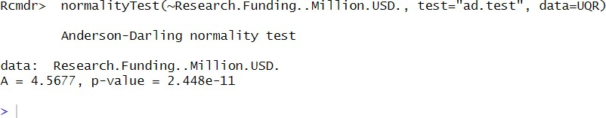

Decision: p-value=2.448e-11< α=0.05=>Reject H0 at 5% significant level

Lillie Test
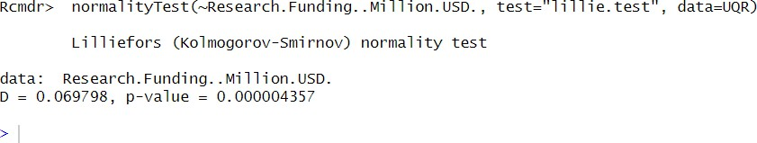

Decision: p-value=0.000004357< α=0.05=>Reject H0 at 5% significant level

Shapiro Test

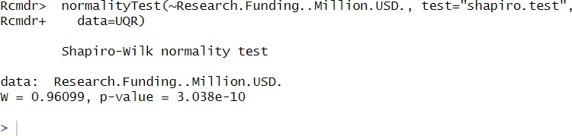

Decision: p-value=3.038e-10< α=0.05=>Reject H0 at 5% significant level

Normality Test Conclusion: According to the Anderson Darling Test (p= 2.448e-11), Lillie Test (p= 0.000004357) and Shapiro Test (p= 3.038e-10), Null hypothesis I rejected that Research funding values across higher education institutions are normally distributed at the 5% significance level.
Therefore, the alternative hypothesis is accepted, indicating that the research funding values are not normally distribute.

Graphical Analysis of Research Funding

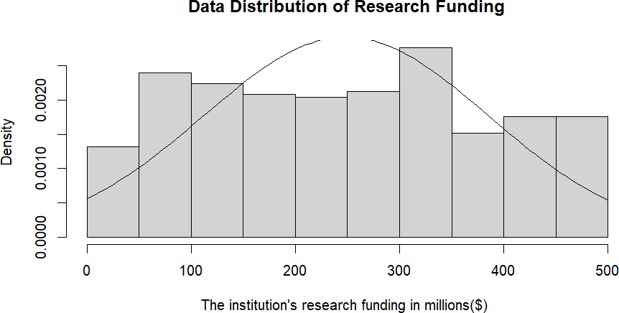

As seen on (Figure 16), the histogram of research funding reveals a relatively uniform and slightly right skewed distribution, with more institutions concentrated between $50M to $350M and fewer at the extremes. This deviating from the ideal bell curve. Therefore, the research funding values across higher education institutions are not normally distributed at 5% significance level.

Statistical Hypothetical Testing: Normality Test for sample: Graduation Rate Dataset: Graduation Rate
- Sample field: Graduation rate
- Significant Level (α):0.05(5%)
- Confidence Level: 95%

(*) Whether or not Graduation Rate values across higher institutional are normally distributed?

H0: Graduation Rate values across higher education institutions are normally distributed.
H1: Graduation rate values across higher education institutions are not normally distributed.

Anderson Darling Test

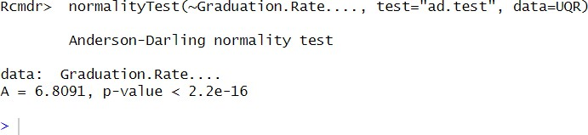
Decision: p-value=2.2e-16< α=0.05=>Reject H0 at 5% significant level

Lillie Test
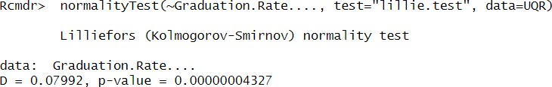

Decision: p-value=0.0000004327< α=0.05=>Reject H0 at 5% significant level

Shapiro Test

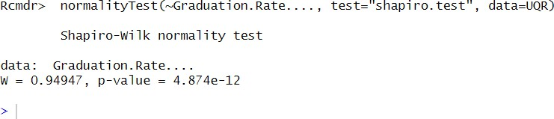

Figure 1.Shapiro Test for Graduation rate
Decision: p-value=4.874e-12< α=0.05=>Reject H0 at 5% significant level

Normality Test Conclusion: According to the Anderson Darling Test (p=2.2e-16), Lillie Test(p=0.00000004327) and Shapiro Test(p=4.874e-12), Null hypothesis is rejected that graduation rate values across higher education institutions are normally distributed at the 5% significance level. Therefore, the alternative hypothesis is accepted, indicating that the graduation rate values are not normally distributed.

Graphical Analysis of Graduation Rate

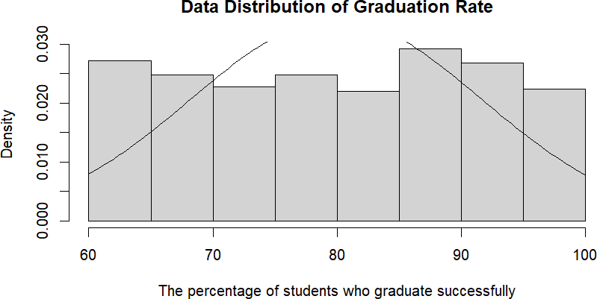

As seen on (Figure 20), the histogram of graduation rate shows a relatively uniform and slightly right skewed distribution, deviating from the ideal bell curve. Therefore, the graduation rates values across higher education institutions are not normally distributed at 5% significance level.

Critical Discussion: Normality Test Findings in the context of Sri Lanka’s Higher Education Sector.
The results of the normality test across all key variables in the University Ranking (UQR) dataset reveal that none of the examined variables follow a normal distribution at the 5% significance level. This finding has several important implications for understanding the structural characteristics and disparities within Sri Lanka’s higher education system.
The University Ranking Scores, despite appearing somewhat symmetrical, show a slight right skewness in ranking scores shows that a few elite institutions or unies like the university Colombo, university of Moratuwa and university of Peradeniya hold top ranks consistently, while many regional universities such as Rajarata University, Uva Wellassa University perform significantly lower. This reflects an imbalance in institutional quality, infrastructure and academic competitiveness.
The skewed student enrollment pattern indicates overcrowding in universities within the western province such as University of Kalaneiya and University of Sri Jayawradanepura where demand exceeds capacity, while universities in rural area like Vavuniya campus of sabaragamuwa University experience under enrollment. This uneven distribution affects classroom quality, resources and student satisfaction.
The non-normal distribution is salaries points to disparities in faculty compensation, where urban universities offer higher pay and better incentives, attracting experienced academics. In contrast, rural institutions like Eastern University struggle to recruit and retain qualified staff, impacting teaching standards. MOHE could address this by introducing salary schemes and academic incentive programs.
Research investment in Sri Lanka is heavily concentrated I top universities like peradeniya, Colombo and Moratuwa while many regional institutions lack sufficient funding. This imbalance limits nationwide innovation and suggests the need for more equitable, performance based funding models.
Universities with better student support such as NSBM, Colombo and Moratuwa show stronger graduate employability, whereas others with weak industry links struggle. Expanding career services and aligning curricula with market needs is crucial to improve outcomes.
Public Universities like Jayewardenepura and Kalaniya face overcrowded classroom due to poor student faculty ratios. This affects learning quality. Addressing this requires increased academic staff and better use of blended learning approaches.
Although public institutions are affordable, private universities such as SLIT and CINEC show wide variations in fees. This inconsistency highlights the need for better regulation to ensure value for money and equitable access without compromising quality.

Correlation Testing

Statistical Hypothetical Testing: Pearson product moment-test for correlation. Analysis of sample: Student Enrollment and university ranking score
- Sample Field: Student enrollment and university Ranking score
- Significance level:0.05(5%)
- Confidence Level: 95%

(*) Whether or not there is a relationship exist between the number of students enrolled in a university and its university ranking score?
H0: There is no correlation exist between student enrollment and university ranking score. H1: There is a correlation exist between student enrollment and university ranking score.
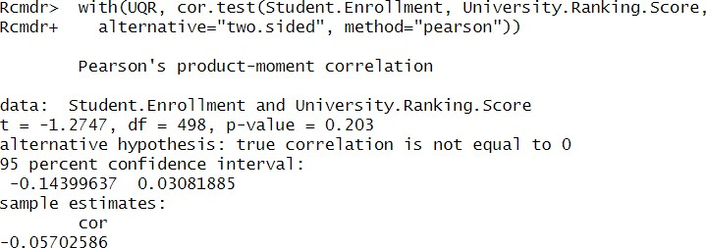

Decision: p-value=0.203> α=0.05-Fail to Reject H0 at 5% significant level

Conclusion: According to the Pearson product-moment correlation test (p=0.203) for correlation analysis, there is not enough evidence to claim a significant linear relationship between the number of students enrolled in a university and its university ranking score at the 5% significant level. The weak correlation coefficient (ῤ =-0.05702586) indicates an almost negligible negative association between these variables.

Graphical Analysis of Student Enrollment Vs University ranking Score

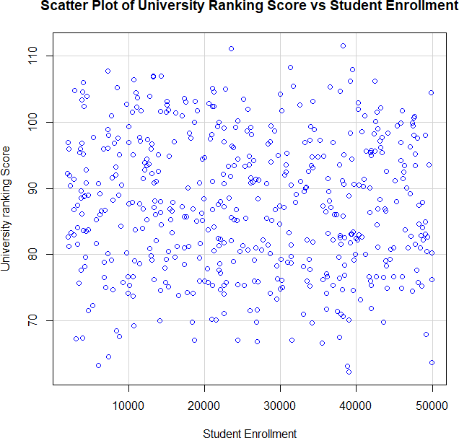

As seen in (Figure 34), the scatterplot of SE vs URS shows a wide dispersion of values with no clear trend or linear pattern. The points appear to be random scattered, suggesting a very weak and negligible relationship between the two variables. This visual observation aligns with the Pearson correlation result(ῤ=-0.057), indicating a very weak negative linear relationship.
Therefore, it can be concluded that there is no meaningful linear association between the number of students enrolled in a university and its overall ranking score.

Statistical Hypothetical Testing: Pearson Product moment-test for correlation. Analysis of sample: Faculty Salary and university ranking score
- Sample Field: Faculty Salary and University ranking score

- Significance Level:0.05(5%)
- Confidence level: 95%

(*) Whether or not there is a relationship exist between the average faculty salary in a university and its university ranking score?
H0: There is no correlation exist between the average faculty salary in a university and its university ranking score.
H1: There is a correlation between the average faculty salary in a university and its university ranking score.
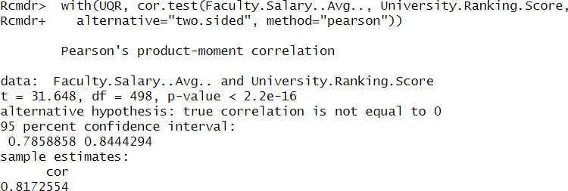

Decision: p-value=2.2e-16< α=0.05=>Reject H0 at 5% significant level
Conclusion: According to the Pearson product-moment correlation test (p<2.2e-16) for correlation analysis, there is strong statistical evidence to claim a significant linear relationship between the average faculty salary and the university ranking score at the 5% significant level.
The correlation coefficient(ῤ=0.8172554) indicates a strong positive linear association between these two variables. This suggests that universities offering higher average faculty salaries tend to have higher ranking scores, possibly reflecting greater investment in academic quality and institutional performance
Graphical Analysis of Faculty Salary(Avg.) vs University Ranking Score

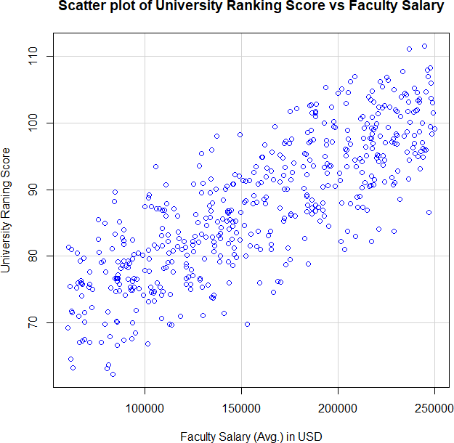

As seen on (Figure 36), the scatterplot of Faculty Salary Vs University Ranking Score shows a clear upward trend with tight clustering of data points along a rising line. This pattern visually confirms a strong positive relationship This visual pattern supports the correlation result(ῤ=0.817), confirming that higher faculty salaries are generally linked with higher university ranking The graph reinforce the statistical finding that faculty compensation may play a key role institutional performance.

Statistical Hypothetical Testing: Pearson Product moment-test for correlation. Analysis of sample: Research Funding and university ranking score

- Sample Field: Research Funding and University Ranking Score
- Significance Level:0.05(5%)
- Confidence Level: 95%

(*) Whether or not there is a relationship exist between the Research Funding in a university receives and its university Ranking Score?
H0: There is no correlation between research funding and university ranking score. H1: There is a correlation between research funding and university ranking score.
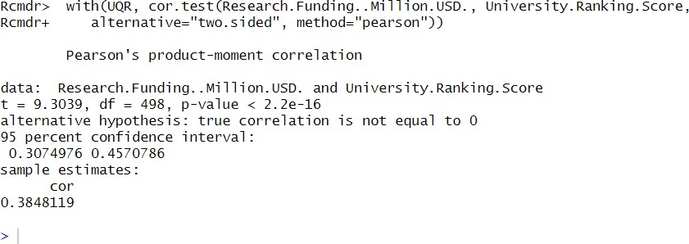
Decision: p-value<2.2e-16< α=0.05=>Reject H0 at 5% significant level
Conclusion: According to the Pearson product-moment correlation test (p<2.2e-16), there is strong statistical evidence to conclude that a moderate positive linear relationship exists between research funding and university ranking score.
The correlation coefficient(ῤ=0.385) indicates that as research funding increase, universities tend to have higher ranking scores. Although the relationship is not very strong, it is statistically significant and suggest that research investment may positively influence institutional ranking performance.

Graphical Analysis of Research Funding and University Ranking Score

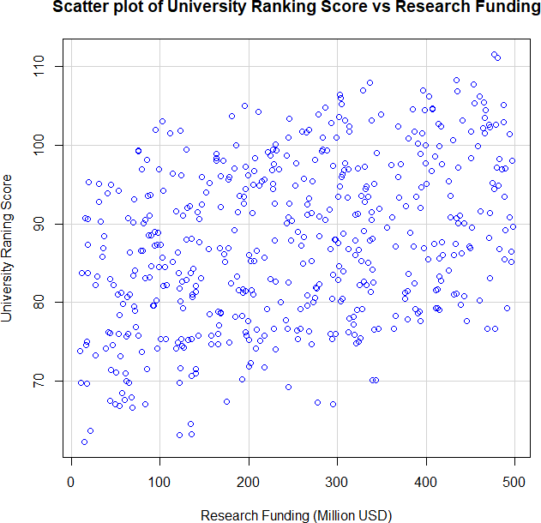

As seen on (figure 38), the scatterplot of Research Funding (Million USD) vs University Ranking Score demonstrates a moderate upward trend with visible, though somewhat dispread, data points.
The pattern suggests that institutions receiving higher research funding generally achieve higher ranking scores. This visual trend supports the Pearson correlation result(ῤ=0.385) and confirms a moderate positive association between these two variables.

Graphical Analysis of Graduation Rate vs University Ranking Score

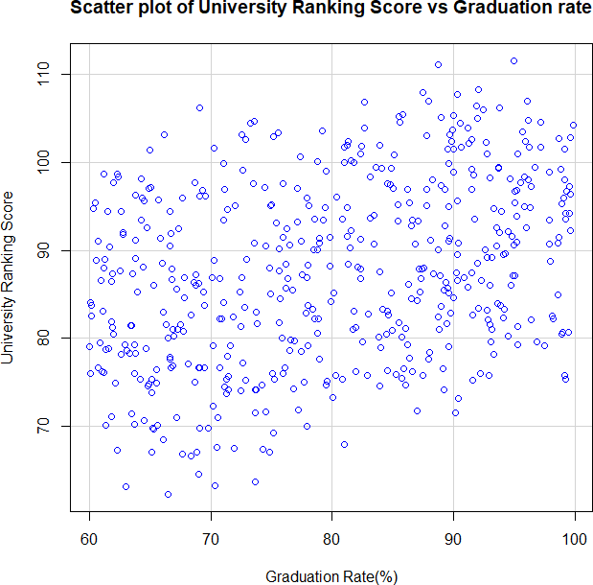

As seen on (Figure 40), the scatterplot of Graduation Rate (%) versus University Ranking Score displays a moderate upward trend, with a moderate clustering of data points along a rising line. This visual pattern supports the Pearson correlation result (ῤ=0.349), indicating a moderate positive association between the graduation rate of a university and its overall ranking score. The graphical trend reinforces the statistical conclusion that higher graduation success rates are generally linked with better institutional rankings.

Statistical Hypothetical Testing: Pearson Product moment-test for correlation. Analysis of sample: Student-Faculty Ratio and University Ranking Score

- Sample Fields: Student Faculty Ratio and University Ranking Score
- Significance level:0.05(5%)
- Confidence level:95%

(*) Whether or not in a relationship between the student faculty ratio and the university ranking score
H0: There is no correlation between student faculty ratio and university ranking score H1: There is a correlation between student faculty ratio and university ranking score

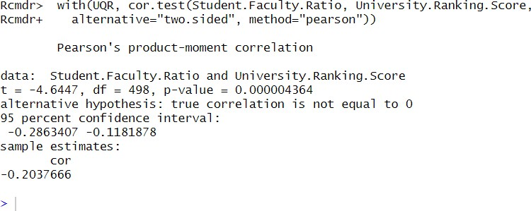

Graphical Analysis of Student Faculty Ratio vs University Ranking Score

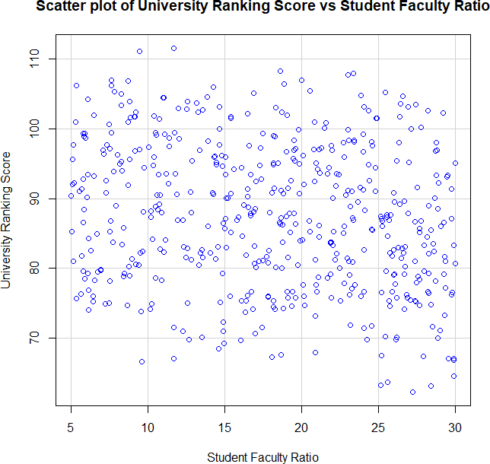

As shown in (Figure 42), the scatterplot of SFR vs URS displays a slight downward trend with data points moderately scattered. This pattern supports the Pearson correlation result (ῤ=-0.204) and suggests a weak but negative association, where universities offering better student to faculty access are more likely to achieve higher ranking scores.

Statistical Hypothetical Testing: Pearson Product moment test for correlation. Analysis of sample; Tuition Fees(USD) and University Ranking Score

- Sample Fields: Tuition Fees and University Ranking Score
- Significance level:0.05(5%)
- Confidence level: 95%

(*) Whether or not there is a relationship between tuition fees charged by a university and its university ranking score?
H0: There is no correlation between tuition fee and university ranking score. H1: There is a correlation between tuition fees and university ranking score.

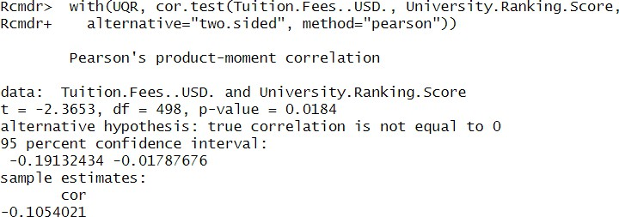

Decision: p- value =0.0184< α=0.05=> Reject H0 at 5% significant level
Conclusion: According to the Pearson product moment correlation test (p= 0.0184), there is statistical evidence to suggest a weak but significant negative linear relationship between tuition fees and University Ranking score at the 5% significant level.
The correlation coefficient (ῤ= -0.1054021) indicates that universities with higher tuition fees tend to have slightly lower ranking scores. Although the strength of the relationship is weak. It is statistically significant, which may suggest that factors associated with higher tuition could impact ranking scores.

Graphical Analysis of tuition Fees Vs University Ranking Score

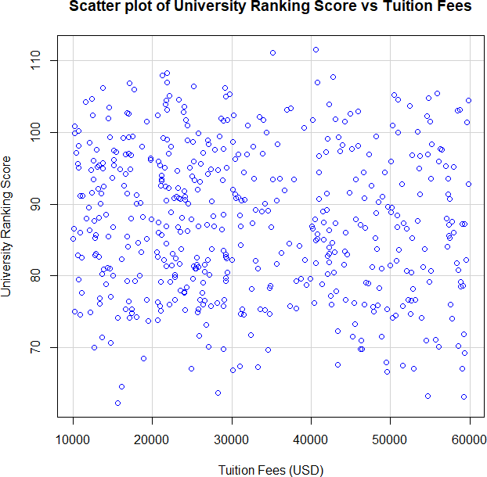

As shown in (Figure 44), The scatterplot of TF(USD) vs URS relieves a mild downward trend, with data points loosely dispersed. This visual trend supports the statistical result(ῤ=-0.105), indicating a weak negative association between TF and URS. While the downward slope is suitable, it suggests that as tuition increases, university ranking scores may slightly decrease, possibly due to variations in affordability, student outcomes or institutional perceptions.

Statistical Hypothetical Testing: Pearson Product moment test for correlation. Analysis of sample: Employment Rate (%) and University Ranking Score
- Sample Fields: Employment Rate and university Ranking Score
- Significance level:0.05(5%)

- Confidence level:95%

(*) Whether or not there is a relationship between employment rate of graduate and the university ranking score?
H0: There is no correlation between employment rate and university ranking score. H1: There is a correlation between employment and university ranking score.

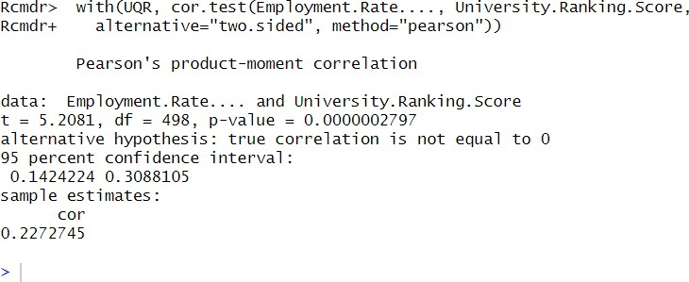

Graphical Analysis of Employment Rate vs University Ranking Score

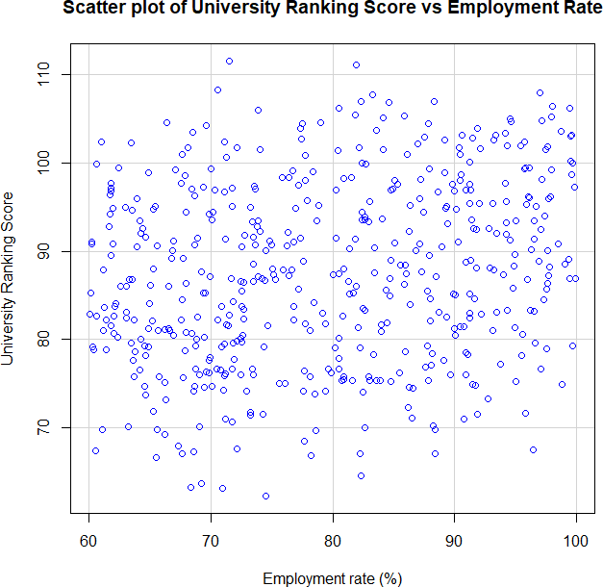

As seen on (Figure 46), the scatterplot of Employment Rate (%) versus University ranking Score displays a mild upward trend with a noticeable spread among data points. The visual slope corresponds to the Pearson correlation coefficient(ῤ=0.227), suggesting a weak positive association between the two variables. The graph supports the conclusion that better employment outcomes for graduate are generally associated with higher university rankings, reinforcing the importance of career support and employability initiative within institutions.

Critical Discussion: Correlation Analysis Findings in the Context of Sri Lanka’s Higher Education Sector
The correlation analysis of the University Quality Ranking dataset reveals several important associations between university performance and institutional factors, offering key insights into challenges and priorities for Sri Lanka’s higher education system.
A significant negative correlation between student faculty ratio and university ranking score suggests that institutions with better access to faculty like the university of Colombo and all universities, especially in under resourced institutions in the Northern and Eastern Provinces, where faculty shortages are more common.
The negative correlation between tuition fees and University Ranking Score challenges the notion that higher cost equals higher quality. In Sri Lanka, public universities offer tuition free education and still rank higher than many fee based institutions. This underlines the importance of transparent tuition regulation and equitable access, especially for economically disadvantages students.
Conversely, a positive correlation between Employment Rate and Ranking Score shows that institutions with stronger graduate outcomes such as the university of Moratuwa tend to perform better overall. This reflects the need for stronger industry partnerships, career services, and relevant academic programs, particularly in universities located in less urbanized regions. The lack of significant correlation between student enrollment and Ranking score indicates that larger universities do not necessarily perform better. This suggests that MOHE should focus more on quality assurance, student support and infrastructure rather than simply increasing student numbers.
The strong positive correlation between Faculty Salary and ranking Score reinforces the importance of investing in academic human capital. Top tier institutions offer better compensation, attracting qualified faculty. Equalizing salary structures and offering rural service incentives could help reduce performance gaps across universities.
The moderate positive correlations between Research funding and Graduation Rate with University Ranking Score suggest that better research capacity and academic support enhance institutional performance. To improve outcomes nationwide, Sri Lanka must expand research funding, mentorship and curriculum reforms.

Simple Linear Regression Analysis
Statistical Hypothetical Testing: Simple Linear Regression-tests for modeling of Samples: UQR New: University Ranking Score and Faculty Salary
- Sample dataset: UQR
- Significant level(α):0.05(5%)
- Confidence level: 95%

Linear general model

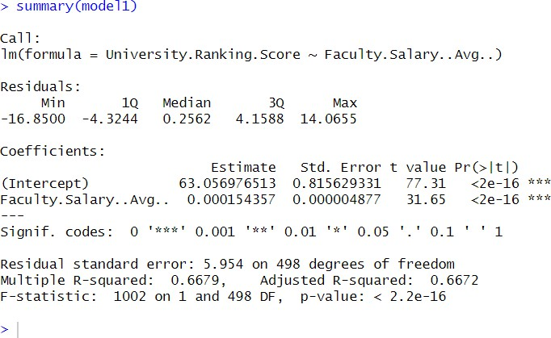
YURS = a + b XFS

Figure 2.Regression Analysis

Final linear Mode
YURS = 64 + 0.000154357 XFS

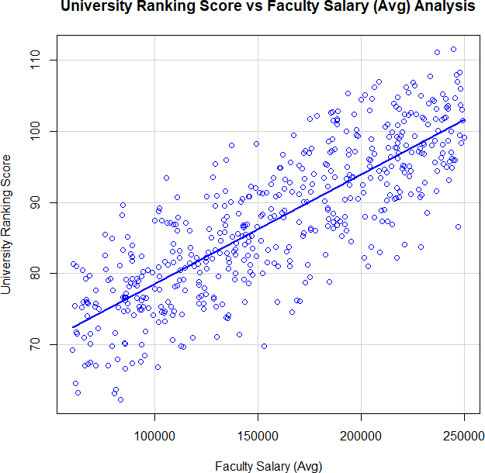

The regression analysis in Figure 42 reveals a strong positive linear relationship between Faculty Salary and university Ranking Score. For every $1 increase in salary, the ranking score increases by approximately 0.00015, with an intercept of 63.06. The relationship is statistically significant at the 5% level (p<2e-16).
With an R² of 0.6679, the model explains 66.7% of the variation in university ranking score based on faculty salary, indicating moderate to high accuracy. However, a residual standard error of 5.954 suggests that other factor also influence ranking score.

Statistical Hypothetical Testing: Simple Linear Regression-tests for modeling of Samples: UQR New: university Ranking Score and Research funding

- Sample Dataset: UQR
- Significance Level(α):0.05(5%)
- confidence Level: 95%

Linear general Model
YURS= a + b XRF

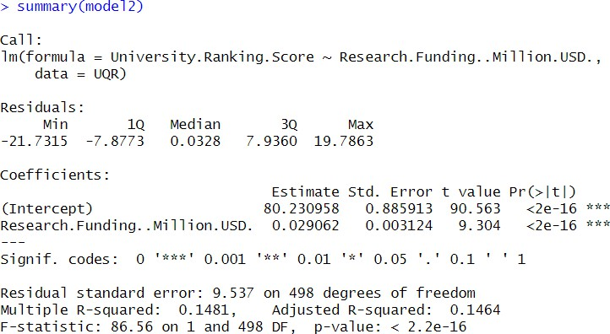
Final Linear Model

YURS = 80 + 0.029062XRF

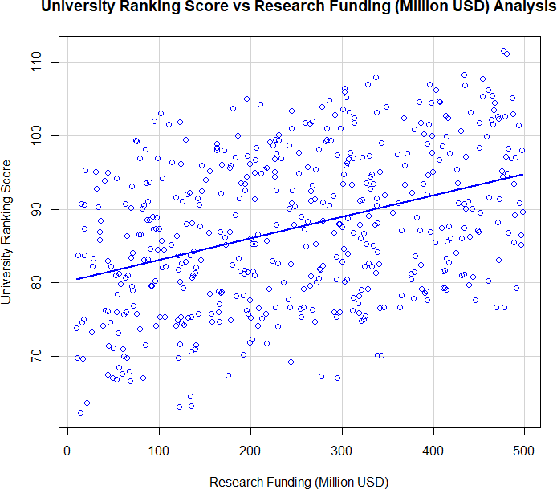

Figure 3.scatterplot of URS vs RF

According to the linear model generated by regression analysis, as seen on Figure 50, it is clear to identify that the values are moderately aligned along a straight line, forming a positive but weak linear tend. Therefore, the model clearly indicates that the University Ranking Score is influenced by Research Funding at a 5% significance level, supported by a highly significant p-value(<2e- 16). However, the model accuracy is relatively low, with R²=14.81% and adjusted R²=14.64%, indicating that research funding alone explains only a small portion of the variation in university rankings. The residual standard error of 9.537 also suggests notable deviations in prediction. This implies that while research has some effect on university rankings, other influential variable must be considered to build a more accurate model.

Statistical Hypothetical Testing: Simple Linear Regression-tests for modeling of Samples: UQR New: University Ranking Score and Graduation Rate
- Sample Dataset: UQR
- Significance Level(α):0.05(5%)
- Confidence Level: 95%

Linear general Model

YURS = a + b XGR

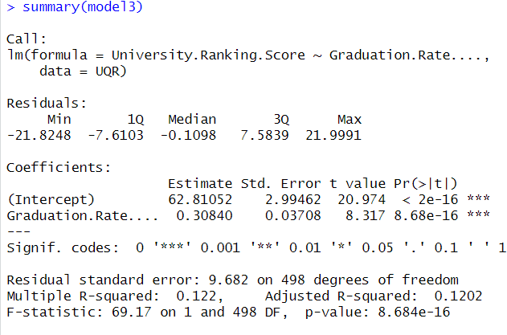

Final Linear Model
YURS= 63 +0.30840 XGR

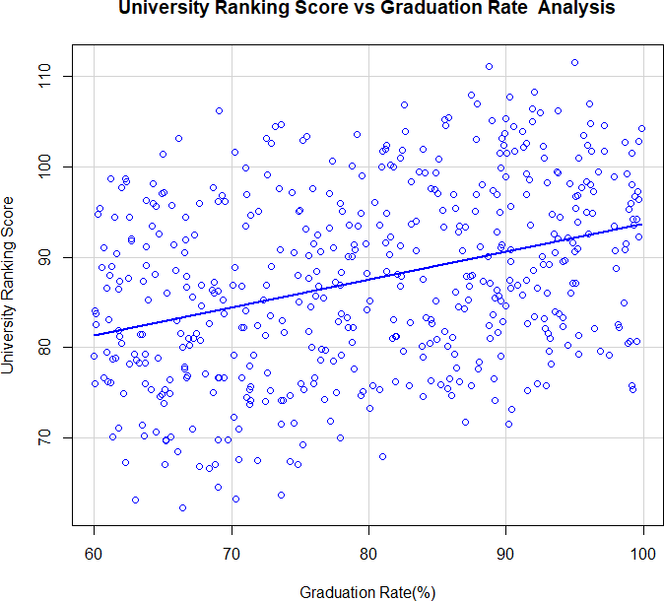

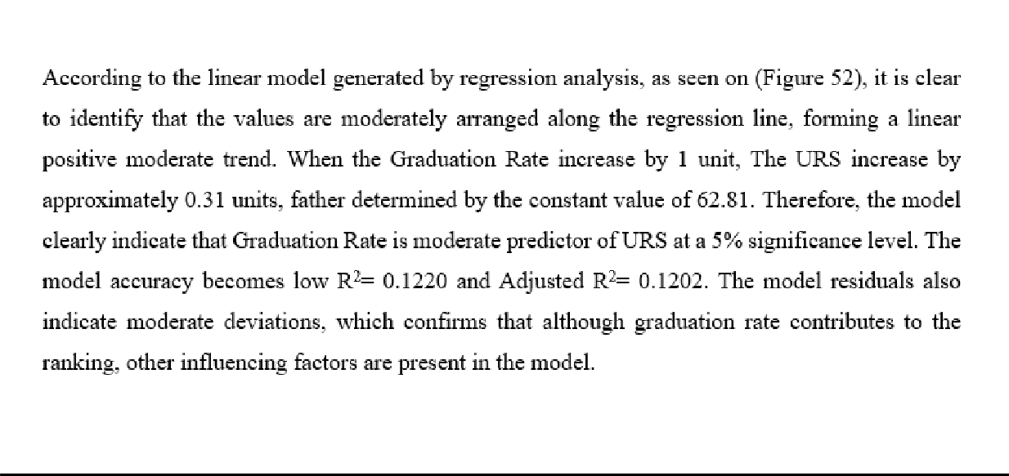

Statistical Hypothetical Testing: Simple Regression-tests for modeling of Samples: UQR New: University Ranking Score and Employment Rate
- Sample Dataset: UQR
- Significance Level(α):0.05(5%)
- Confidence Level: 95%

Linear general Model

Yurs = a + b XER

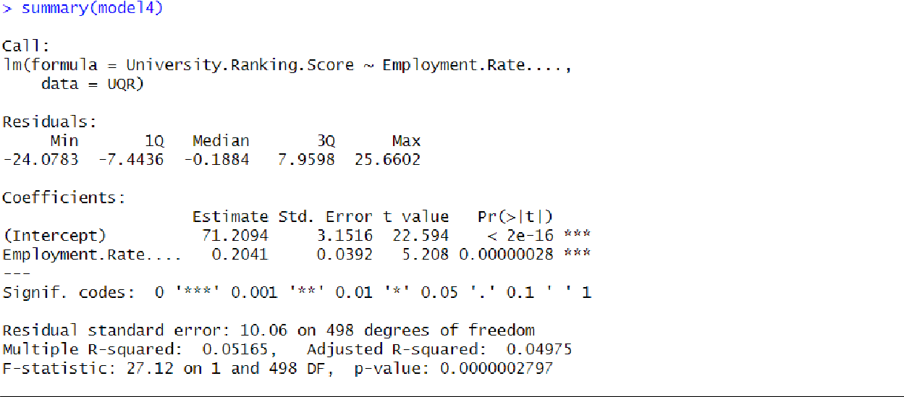
Final Linear Model

YURS = 71 + 0.2041 XER

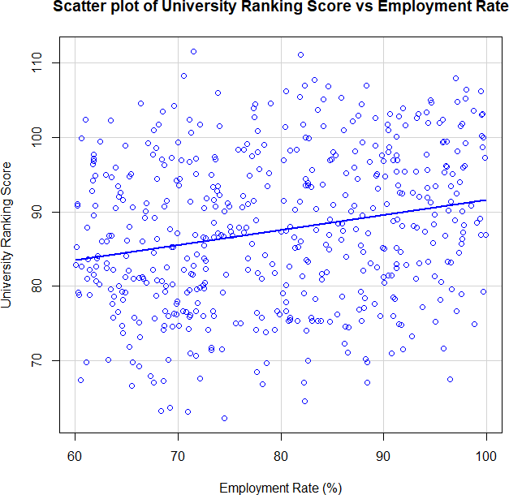
According to the linear model generated by regression analysis, as seen on (Figure 54), It is clear to identify that values are arranged loosely along the regression line, forming a week linear positive trend. When the Employment Rate increase by 1 unit, the university Ranking Score increase by approximately 0.204 units, with a constant base value of 71.21. The model shows statistical significance at a 5% level (p< 0.001), but its accuracy is very low with R²- 0.0516 and Adjusted R² = 0.0497. The residuals also reflect wider deviations, indicating that while employment rate has an effect, its influence on university ranking is limited and uncertain in practical prediction.

Statistical Hypothetical Testing: Simple Regression-tests for modeling of Samples: UQR New: University Ranking Score and Student Faculty Ratio

- Sample Dataset: UQR
- Significance Level(α): 0.05(5%)
- Confidence Level: 95%

Linear general Model+
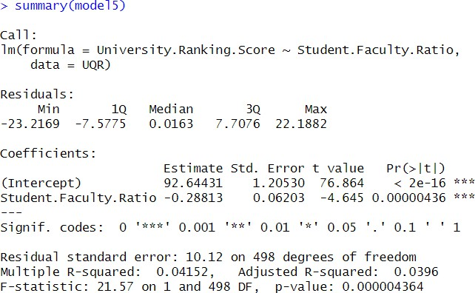
YURS = a + b XSFR

Final Linear Model

YURS = 93 + (-0.28813) XSFR

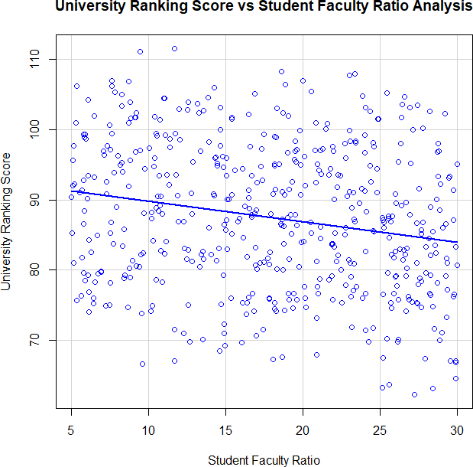

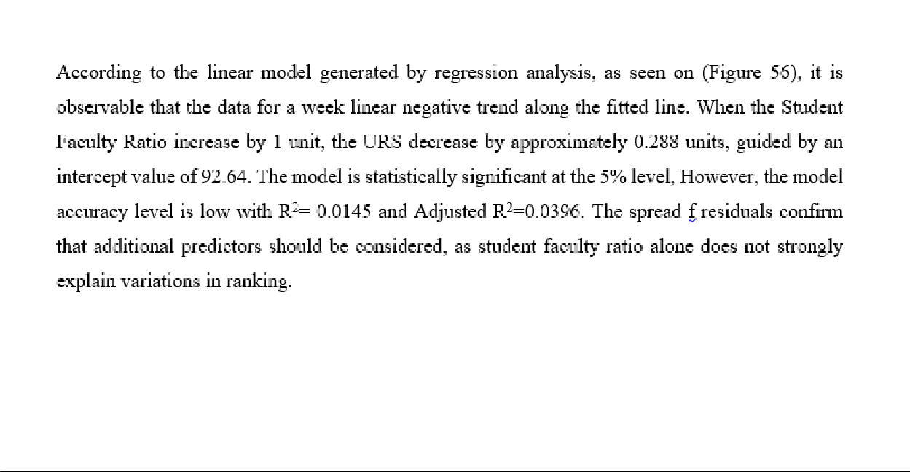

Statistical Hypothetical Testing: Simple Regression-test for modeling of Samples: UQR New: University Ranking Score and Tuition Fes
- Sample Dataset: UQR
- Significance Level(α):0.05(5%)
- Confidence Level: 95%

Linear general Model

YURS = a + b XTF

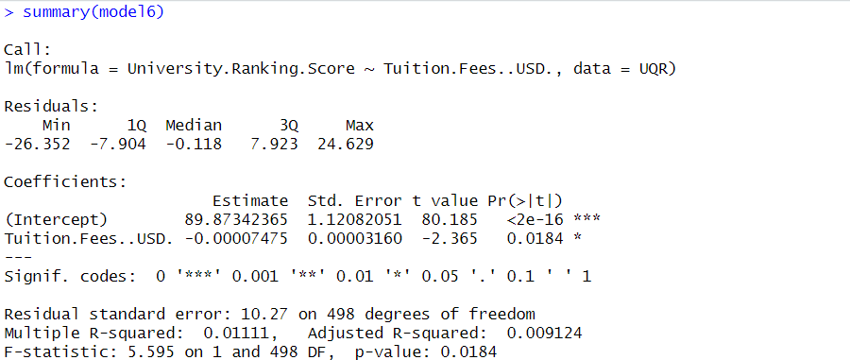

Final Linear Model
YURS = 90 + (-0.00007475) XTF

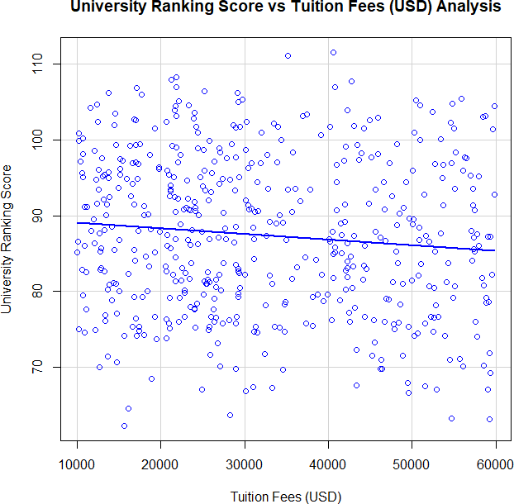

According to the linear model generated by regression analysis, as seen on (Figure 58), a very weak linear negative trend can be identified between tuition fes and university Ranking When Tuition Fees increase by 1$, the University Ranking Score decrease by 0.00007475 units, with a baseline intercept of 89.87. Though statistically significant (p 0.0184), the model demonstrates very low predictive accuracy, with R² = 0.0091. The high residual values indicate that Tuition Fes alone are not a reliable determinant of university rankings.

Critical Discussion: Regression Analysis Finding in Sri Lanka’s Higher Education Sector.

The regression analysis highlights the varying degrees to which individual factors explain the variation in university ranking scores across Sri Lankan higher education institutions, providing valuable insights for policy and institutional improvements.
Faculty Salary emerges as the strongest predictor, explaining approximately 66.7% of the variation in ranking scores (R² = 0.6679). This strong positive relationship implies that universities offering better faculty compensation, such as the university Colombo and university of Moratuwa, are more likely to achieve higher rankings. This underscores the critical role of investing in academic human capital. To reduce disparities, MOHE should consider salary standardization and incentive programs that help attract and retain quality faculty across all unies including those in less developed regions.
In Sri lanka, Research Funding is statistically significant but explains only a small portion R²=14.8% of the variation in University Rankings. This suggests that while funding boosts prestige, its current concentration in elite institutions like Colombo and Peradeniya limits nation impact. A more equitable funding model is essential to strengthen research capacity across all unies.
The Graduation Rate explaining R²=12.2% of ranking variance, highlights the role of student support systems. Universities with strong academic advising and structured programs such as Peradeniya and NSBM perform better. Expanding such support across regional institutions could improve national outcomes.
Employment Rate has weak influence R²=5.2% on rankings, suggesting employability isn’t enough. Many graduates face skill mismatches in the job market. This underlines the need for stronger industry partnerships and practical learning programs.

The student faculty ratio shows a very low predictive value R²=1.45%. While overcrowding remains an issue especially in Jayewardenepura and Kelaniya, it must be addressed alongside border reforms like hybrid learning and faculty development.
Lastly, Tuition fees show almost no effect R²=0.9%. reflecting that Sri Lanka’s free public education model does not comprise quality. However, regulation of private institutions remains important to ensure affordability and academic value.

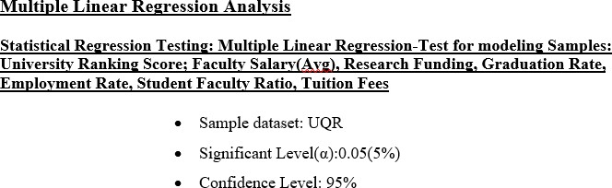

Multiple Linear general models

YURS = a + b1. Xfaculty Salary + b2. XResearch Funding + b3.XGraduation Rate + b4.XEmployment Rate + b5.XStudent Faculty Ratio+ b6.XTution Fees

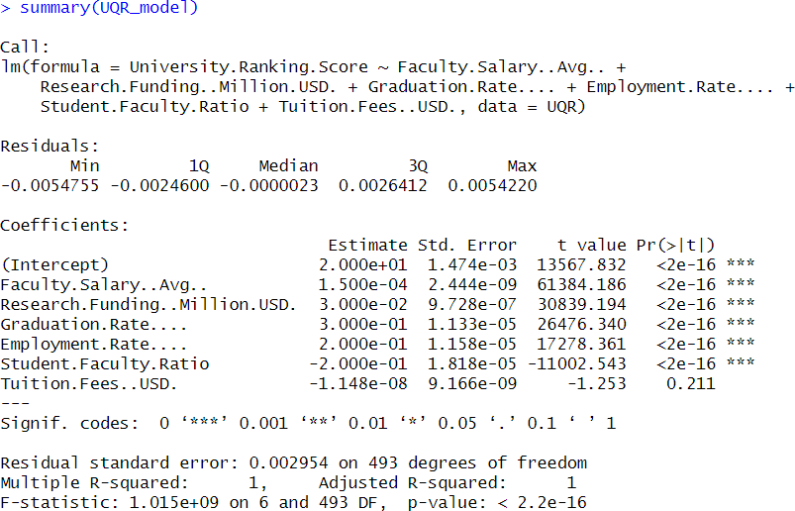

Multiple Linear General Model

YURS=20.00 + (0.00001500.Xfaculty salary) + (0.003000.XResearch funding) + (0.2000.XGraduation rate) + (0.2000.XEmployment Rate) - (0.2000.Xstudent faculty ration) - (0.0001148.XTution fees)

Conclusion of whole analysis
According to the Pearson product-moment correlation test, Faulty salary showed a strong positive correlation (ῤ = 0.817) with university Ranking Score at a 5% significance level, indicating higher faculty pay contributes to better institutional performance. Research funding (ῤ=0.385), (ῤ=-0.204) and Tuition Fees (ῤ=-0.105) had weak but statistically significant negative correlations with University Ranking Score. Student Enrollment showed no statistically significant correlation (ῤ=
-0.057, p =0.203), indicating that the number of enrolled students does not significantly affect a university’s ranking.
As per the results of the simple linear regression analysis based on University Ranking Score as the response variable and explanatory variables such as Faculty Salary, Research Funding, Graduation Rate, Employment Rate, Student-Faculty Ratio, and Tuition Fees, the strongest model fitness value (R² =0.6679, Adjusted R²=0.6657) was observed for the regression model based on Faculty Salary YURS= 63.06 + 0.00015XFS, indicating that Faculty Salary is the most influential predictor of University Ranking Score among the variables tested.

The regression model for Research Funding (R² = 0.1481), Graduation Rate (R² = 0.1220), and Employment Rate (R² = 0.0516) confirmed statically significant relationships but with low to moderate predictive power. Models for student faculty ratio (R² = 0.0145) and Tuition Fees (R²
=0.0091) showed very low explanatory power, even though statistically significant, suggesting limited predictive utility in isolation.
By considering the overall findings of the research, it is evident that to enhance university quality and competitiveness in Sri Lanka’s Higher Education Sector, greater attention should be given to increasing faculty salaries, allocating sufficient research funding and improving student graduation and employability outcomes. Additionally, while structural factors like student faculty ratio and tuition fees show weaker direct effects, they should still be optimized as part of a border institutional quality strategy. Strategic decision making should be driven by evidence-based models like these to ensure equitable and sustainable improvements across both state and private higher education institutions in the country.

Critical Discussion Relating to Sri Lanka’s Higher Education Sector
The analysis reveals that key factors such as faculty salary, research funding, graduation rate and employment rate significantly influence university rankings. In Sri Lanka, low faculty compensation limits the ability to retain qualified staff, highlighting the need for better academic incentives. Limited research funding is another challenge- national research schemes and industry partnerships should be prioritized to boost innovation.
Graduation and employment rates are also important, improving employability through industry aligned programs and internships is essential. The negative impact of high student faculty ratios suggests that overcrowded classes reduce quality- this can be addressed by hiring more faculty and adopting blende learning. Finally, tuition fees were not strongly linked to rankings. Supporting Sri Lankan’s model of quality improvement through better resource use rather than fee hikes.

TASK(B)

Base Map 1: Total Schools by Administrative District Sri Lanka
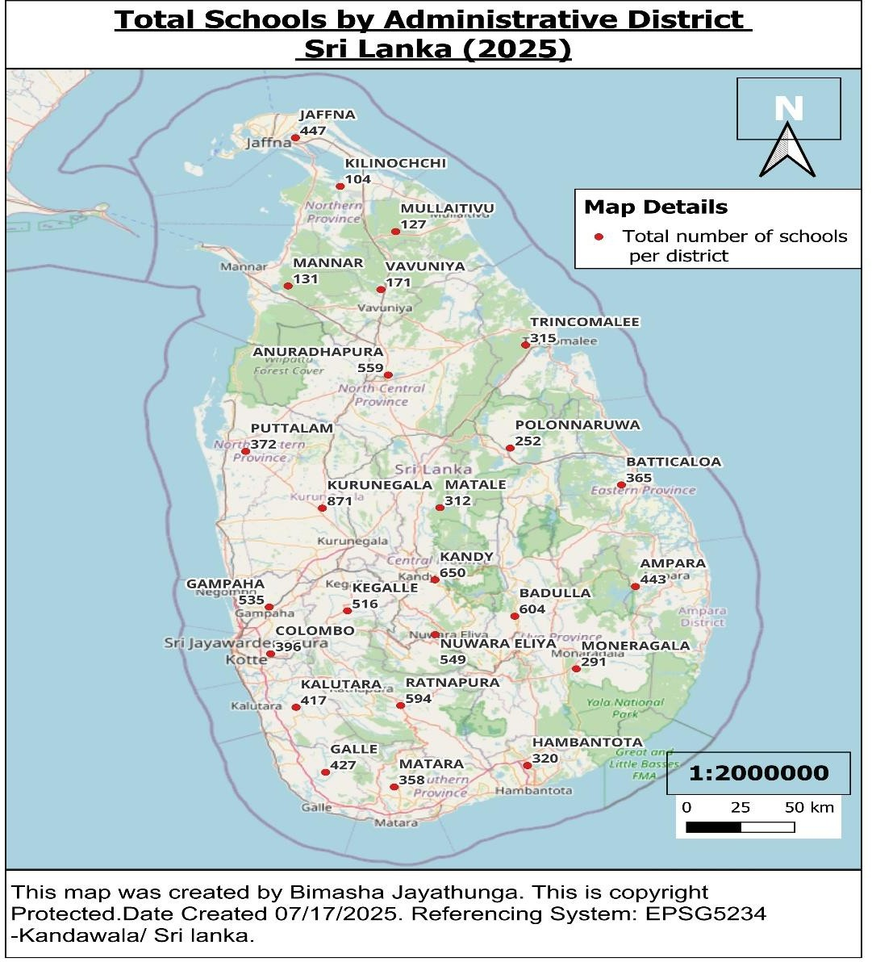

Introduction
This map visualizes the total number of schools in each district across Sri Lanka. It provides a holistic overview of school availability, combining national and provincial. The districts are labeled as in red points, helping identify which regions are more densely served by educational institutions. Notably, districts like Kurunagala, Kandy and Rathnapura appear to have the highest number of total schools, reflecting their population sizes and rural spread. This map essential for understand the overall distribution and reach of the school network in the country.

Base Map 2: National Schools in Sri Lanka (2025)
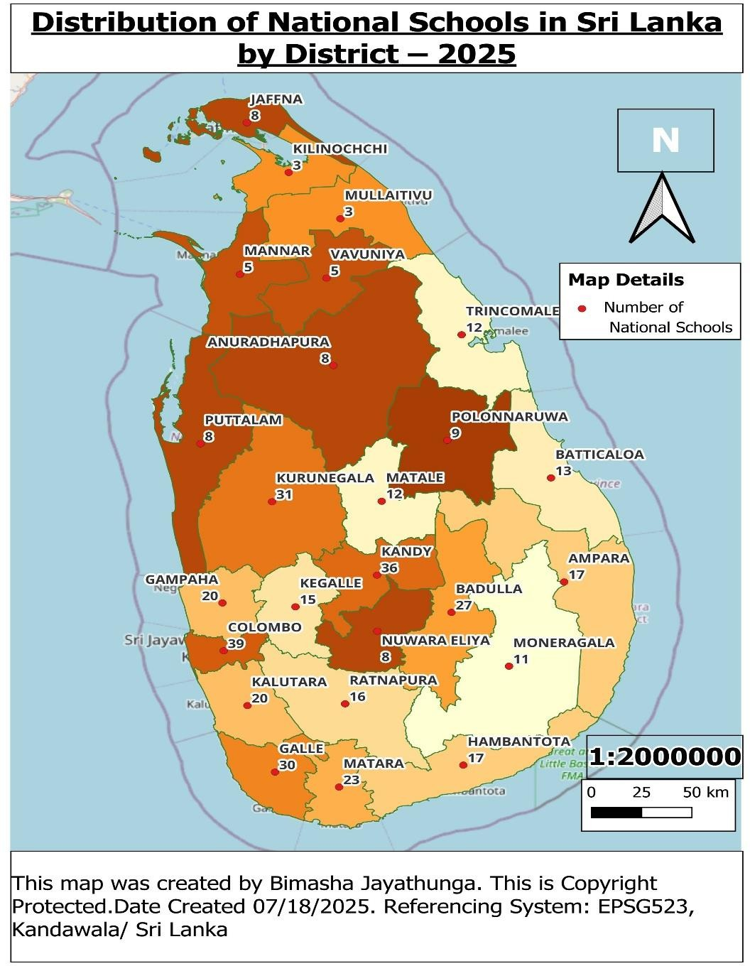

Introduction
The second map represents the distributions of national schools, color coded by the number of schools per district. These schools, managed by the Ministry of education, offer higher quality facilities, qualified teachers and completive academic environments. the map highlights and urban concentration, with district such as Colombo, Kandy and Galle having the most national schools. Though fewer in number, these schools hold prestige and attract students from across regions. This map, alongside the Total schools’ map, helps visualize where centralized educational resource are focused and how they impact overall quality and acces..

Base Map 3: Provincial schools in Sri Lanka (2025)

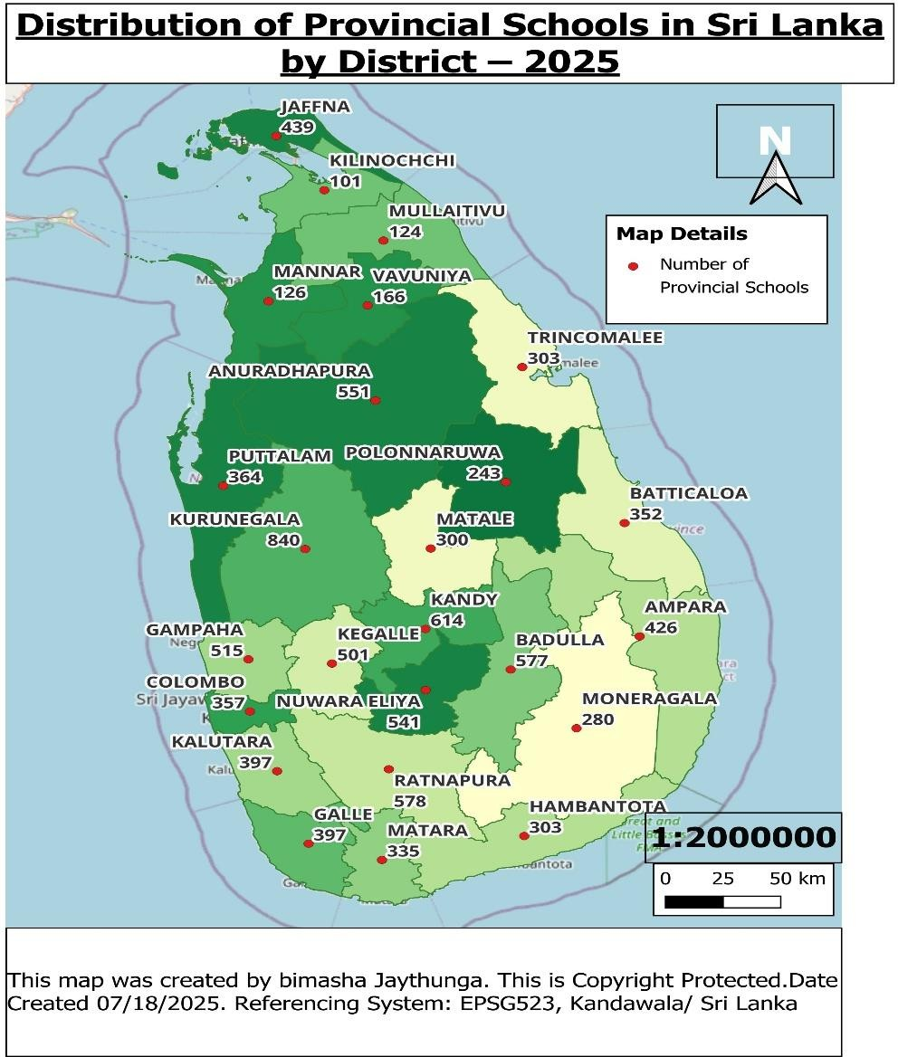

Introduction
The third map illustrates the distribution of provincial school across Sri Lanka, using color coding based on the number of school per district. Managed by provincial council, these schools are particularly in rural and semi urban areas. Districts such as Kurunagala, Rathnapura and Badulla show a high number, reflecting large populations and the need to ensure access in distressed communities. This map helps identify areas where educational infrastructure is widespread but may lack in quality or resource compared to national schools. It highlights the role of provincial schools in addressing basic educational access across the island.

Critical Discussion: Distribution of Schools in Sri Lanka (2025)

The distribution of schools across in Sri Lanka’s administrative districts notable patterns tied to population distribution, historical development, urbanization and regional inequalities. Based on the map visualizing total schools by district, Kurunageala, Kandy, Badulla and Rathnapura emerge as districts with a high number of schools. These are categorized by large populations and expensive geographic coverage, necessitating a higher number of educational institutions to serve widely dispread communities, especially in rural and estate sector. Additionally, these districts have long standing educational infrastructure, often rooted in colonial era policies that favored regional centered.
In contrast, district in the Northern and Eastern Provinces, such as Kilinochchi, Mulaitivu, Mannar and Trincomalee, show comparatively fewer schools. These regions were significantly affected by the civil conflict, leading to years of disruption in educational development and lagging infrastructure investment. Although post-war reconstruction has led to some improvements, these areas still trial behind in terms of the number and quality of educational facilities. To adder this, focused investment is needed to build more schools, upgrade existing one and ensure equitable distribution of educational resources across underserved regions.
When examining the distribution of national schools, a clear urban centric pattern emerges. Districts such as Colombo, Kandy, Galle and Jaffna have a disproportionate share of national schools. These schools often better resources, have qualify teachers and offer advanced curricular and extracurricular programs Their urban locations reflect government policies that historically centralized elite education in metropolitan areas. As a result, student in rural and marginalized regions primarily attend provincial schools, which may suffer from limited facilities, fewer qualified teachers and weaker academic outcomes.
This spatial arrangement points to deep seated educational inequalities. Students from less developed district often lack access to the same quality of education and opportunities available in urban national schools. This imbalance perpetuates intergenerational cycles of disadvantage, as access to high quality education is a key determinant of future socioeconomic mobility. Moreover, while the number of schools in some districts may appear high, it does not necessarily translate to equitable student to school ratios or quality outcomes especially in estate or remote areas while multigrade teaching, lack of subject specific teachers and inadequate infrastructure remains common.

In summary, the map of school distribution in Sri Lanka reflects not only geographic and demographic realities, but also the legacy of centralization, conflict and uneven policy implementation. Addressing these challenges requires a holistic approach one that expands infrastructure where needed but also prioritizes teacher deployment, resource allocation and digital access to reduce the rural urban and north south divides in education.

Task(C)

Base Map: Digitized Geospatial Map of the Ministry of Higher Education

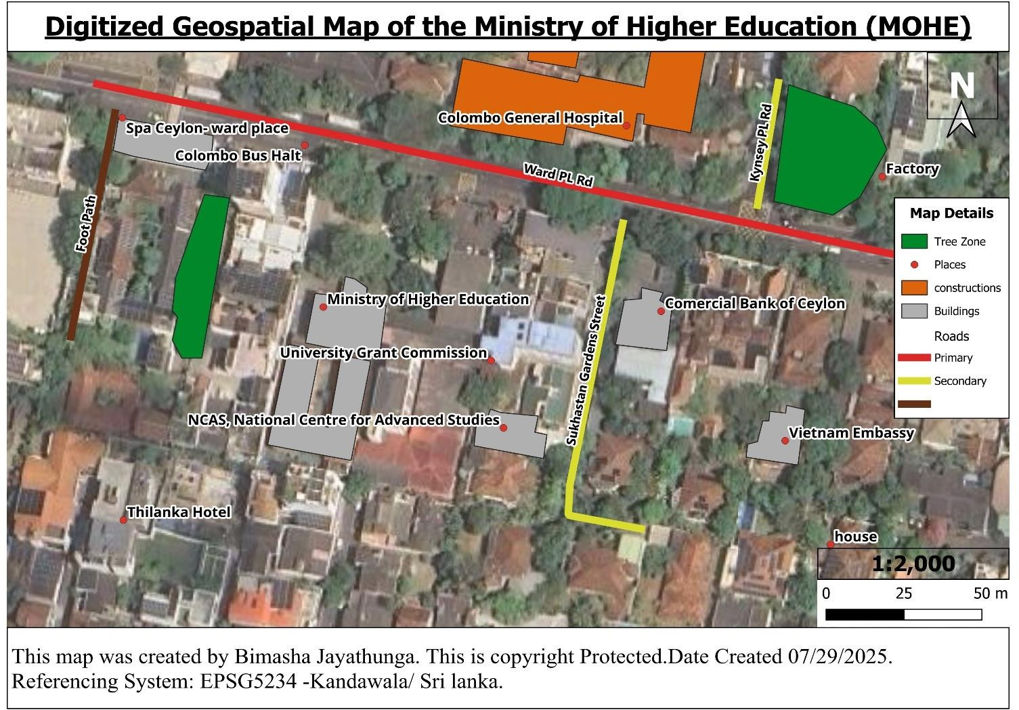

Map introduction
The digitized geospatial map offers a detailed visualization of the Ministry of Higher Education’s (MOHE) location in Colombo, Sri Lanka, specifically in Kandawala’s administrative zone. By incorporating spatial data layers such as roads, buildings, places, roads. tree zone, along with coordinate such as EPSG:5234, the map enable in depth spatial analysis. It highlights how MOHE’s strategic positioning enhances accessibility, infrastructure linkage, and institutional clustering-factors that collectively improve the efficiency and effectiveness of national higher education service delivery (mohe.gov, 2025).

Critical discussion: How MOHE’s Geo location improves efficient and effective service to the National Education System
The geo-location of the Ministry of Higher Education (MOHE), as illustrated in the digitized geospatial map, clearly demonstrates how its spatial positioning contributes significantly to the efficiency and effectiveness of the National Educational System in Sri Lanka. Centrally located within the administrative zone of Kandawala Colombo, the MOHE is surrounded by a cluster of key educational and service institutions, including the University Grants Commission (UGC) and NCAS-National Centre for advanced studies. This close physical proximity allows for seamless institutional collaboration, quick communication and streamlined decision making among top tier administrative bodies responsible for higher education governance.

According to the map, MOHE benefits from excellent transport infrastructure, such as the Colombo bus halt situated nearby and direct access to Ward PL Road (a primary road) and sukhastan gardens street (a secondary street). This make the ministry easily accessible t students, academic, researchers and policy implementers from across the country. The presence of defined footpaths and tree lined zones also enhance pedestrian access and environmental comfort around the site, supporting a more inclusive and eco-friendly institutional environment.

Economically, MOHE’s location adjacent to the commercial bank of Ceylon facilitates the efficient handling of educational funds, grants and transactions. This proximity reduces administrative delays and supports transparent financial operations. Socially, the inclusion of nearby public spaces, diplomatic offices such as the Vietnam Embassy and commercial entities like Spa Ceylon- Ward Place and Thilanka Hotel indicates that the area is well integrated into the border civic and international community. This fosters strong partnerships, inter sectoral coordination and opportunities for international engagement in higher education.

In addition, the digitized map reveals the strategic presence of Colombo General Hospital in the vicinity of MOHE, a major public healthcare facility with critical national importance. From a construction and planning standpoint, the existence of this well-developed hospital infrastructure underscores the urban maturity and accessibility of the area. The hospital is not only vital for public health but also acts as a practical and academic support center for higher education institutions- especially those offering programs in medical sciences, nursing and health administration. Its close proximity ensures that MOHE staff, visiting scholars, and students have immediate access to emergency care, contributing to institutional safety and wellness. It also enables greater collaboration between the Ministry of Health and MOHE in terms of academic partnerships, medical training and policy development on national health education strategies.

MOHE’s geo location provides key social benefits like inclusiveness, health security and strong partnerships, alongside economic advantages such as financial management and easy access via transport links. Globally, proximity to diplomatic missions and advanced geospatial infrastructure supports international cooperation and best governance practice.

However, challenges include social issues like congestion and security concerns, economic drawbacks from high maintenance costs and limited rural outreach and global risks such as diplomatic tensions and constrained expansion. Dependence on local infrastructure may also limit adaptability to emerging digital education trends.
Geographically, the map shows a high concentration of institutional buildings, making MOHE a central hub for educational planning and monitoring. The spatial data layers (with attributes like ID, name, type and size) enable the ministry to utilize geospatial analysis or policy development, campus expansion and resource allocation. Furthermore, the availability of a digitized base map and reference system (EPSG:5234) allows MOHE to synchronize its physical planning with national geospatial systems, leading to smarter governance decisions.

Task(D)

Introduction to the National contribution of MOHE Recognized universities in Sri Lanka

The ministry of Higher Education(MOHE) of Sri Lanka governs a network of public universities that are strategically located across the country. The following table provides the names, districts, and exact geographic coordinated of 18 Key MOHE recognized universities. This spatial distribution reflects the government’s effort to decentralize higher education and ensure regional equity in access to academic resources.

Location Label | District Name | Latitude | Longitude
UOC | Colombo | 6.899886 | 79.858790
UOP | Peradeniya | 7.254847 | 80.597387
UOSJ | Colombo | 6.852638 | 79.903587
UOK | Gampaha | 6.975267 | 79.915565
UOM | Colombo | 6.795006 | 79.900863
UOJ | Jaffna | 9.683774 | 80.023049
UOR | Matara | 5.937963 | 80.576131
EU | Trincomalee | 8.636421 | 81.213188
RU | Anuradhapura | 8.359734 | 80.503311
SU | Rathnapura | 6.714449 | 80.787236
WU | Kurunagala | 7.464435 | 80.021639
UOVAPA | Colombo | 6.909862 | 79.862496
OUOSL | Colombo | 6.882794 | 79.886707
SEU | Ampara | 7.296839 | 81.850036
UWU | Badulla | 6.983042 | 81.079382
SLIT | Colombo | 6.912556 | 79.972956
GSJKDU | Colombo | 6.817529 | 79.890343
BAPU | Kandy | 7.290478 | 80.633681

Base map 1-Main
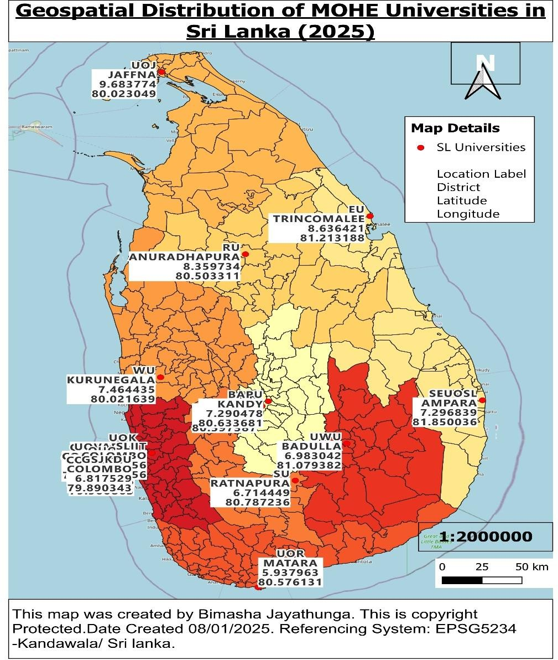

A comprehensive critical discussion on the contribution of MOHE universities to Sri Lanka’s National Higher education and Economic Development

The geographical distribution of universities across sri Lanka reflects a conscious policy by MOHE to decentralize educational infrastructure and increase nationwide access. This map ensures that both densely populated urban centers and remote regions benefit from state funded higher education.
For example, universities such as the UOJ, RU in Anuradhapura and SEU in Ampara serve as vital institutions for unserved and rural populations. These universities contribute not only to human development but also to regional stability, especially in post conflict zones. In contrast, most of universities situated in Colombo, hosts several prestigious universities such as UOC, SLIT and UOM, which serve as national academic and research hubs.

In terms of academic services and contributions, the 18 universities provide a wide range of programs from engineering and IT to medicine, agriculture, arts and defense studies. The UOM and SLIIT have played a major role in advancing engineering and technology sectors, producing graduates that feed directly into Sri Lanka’s industrial and IT sectors. Likewise, the UOP and UOR maintain strong programs in agricultures and environmental science, supporting the country’s agrarian economy. The university of visual and performing arts and the Buddhist pali university offer cultural and spiritual education that preserve the heritage and identity nation. Meanwhile OUOSL has expanded educational accessibility through flexible and distance learning, working professionals.
Economically, these universities serve as major engines of development. In addition to producing skilled graduates, universities stimulate local economics through employment, housing demand, student spending and infrastructure development. Universities like UW and SU have integrated regional economic goals into their program offerings, focusing on entrepreneurship, environmental sustainability, and value added industries. The GSJKDU plays a role by producing personnel for national security, while also offering civilian degrees in medicine and engineering, Yet, challenges remain: universities in less developed areas still face limitations in infrastructure, research funding, and global exposure. These disparities affect the quality and competitiveness of graduates across the system.

According to the MOHE’s official vision, Sri Lanka aims to create a knowledge based society through equitable and accessible higher education. The government’s objectives include improving access to quality education, fostering research and innovation, strengthening university industry partnerships, and aligning programs with national economic priorities. While access has expanded through the establishment of regional universities and OUSL initiatives, significant gaps remain in quality assurance and academic output. Research excellence is still concreated in a few institutions such as Colombo and peradeniya, with most other universities struggling to secure grants or produce impactful publications.
In assessing whether these objectives have been achieved, the answer is mixed. There has been commendable progress in terms of increasing geographic access and program diversity. However, r, the uneven distribution of academic quality, inadequate research infrastructure in regional universities and weak internationalization indicate that the system has not yet fully met its national development goals.
To overcome these limitations and enhance the contributions of universities, several measures are recommended. The government should prioritize more balanced funding, ensuring equitable development across all institutions regardless of location. Research capacity must be enhanced through targeted investments, cross university collaborations and international partnerships. Universities should work more closely with industry to design programs that meet current and future workforce needs, especially in technology, agri and service institutions like the open university, can also increase access while maintaining quality.

In conclusion, the network of MOHE universities in Sri Lanka serves as a foundational pillar for the nation’s socio economic development. Their contribution spans from educating a diverse population and promoting regional equity to supporting the countr’s economic and innovation ecosystem.

Base map 2- road Network Context
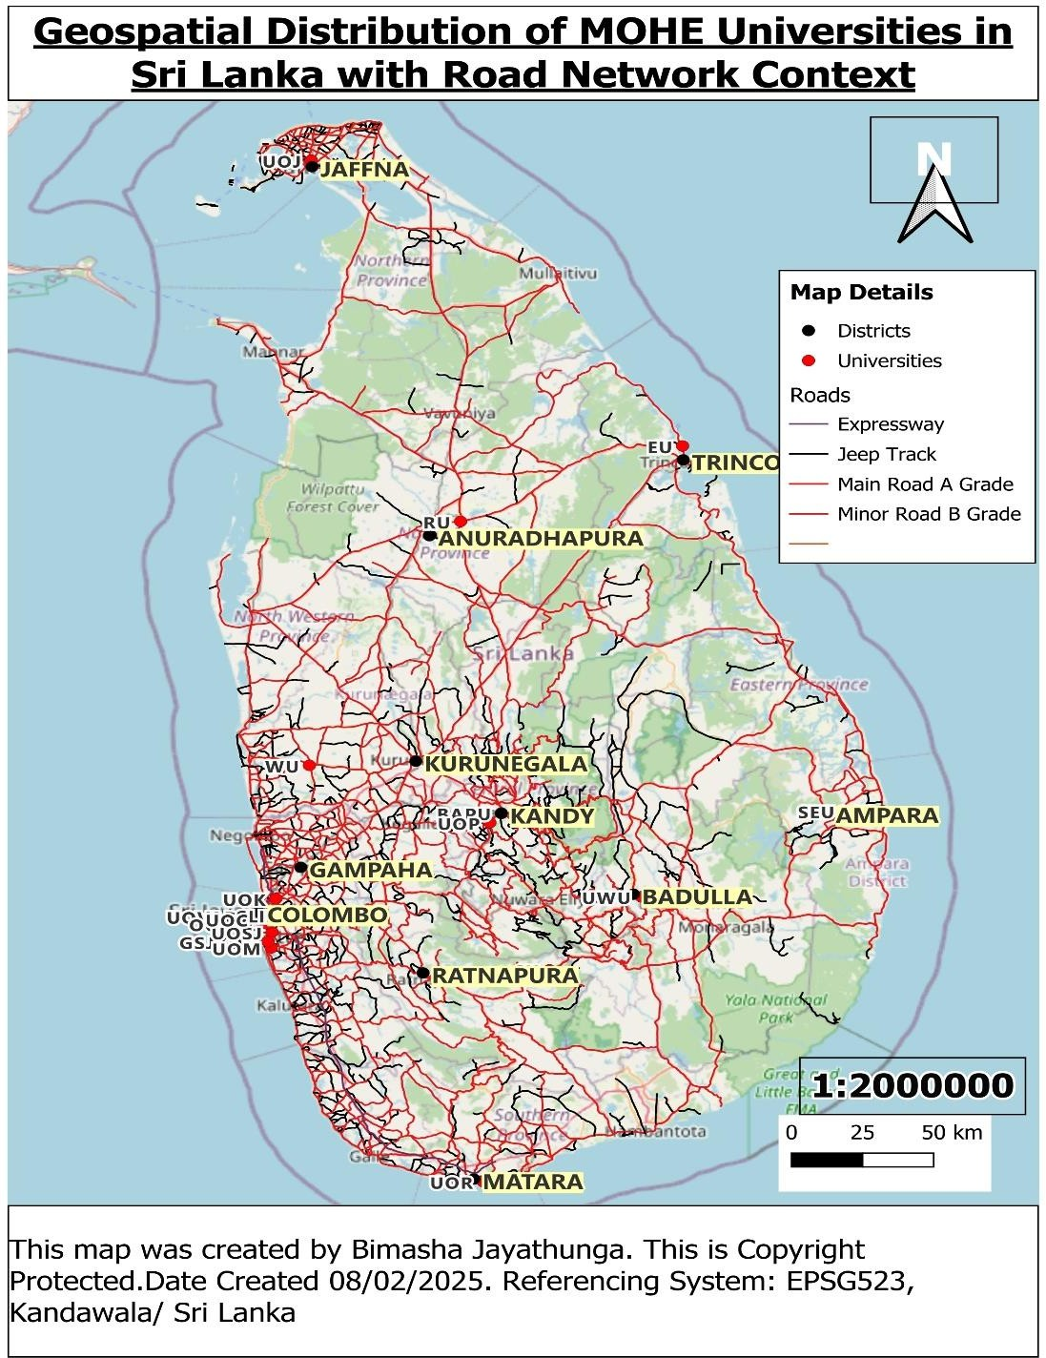

The road network significantly influences the social, economic and institutional landscape of MOHE universities in Sri Lanka. Socially, better road access promotes equal education opportunities by connecting urban and rural populations. Economically, universities near major roads boost local development and attract more students and business. University wise, institutions in Colombo and other well connected areas benefit from accessibility, while remote universities like Jaffna or Sabaragamuwa face challenge. The pros include improved accessibility, regional development and increased collaboration. While cons involve over concentration in urban areas and limited access for rural institutions.

Base map 3- Forest Cover Context
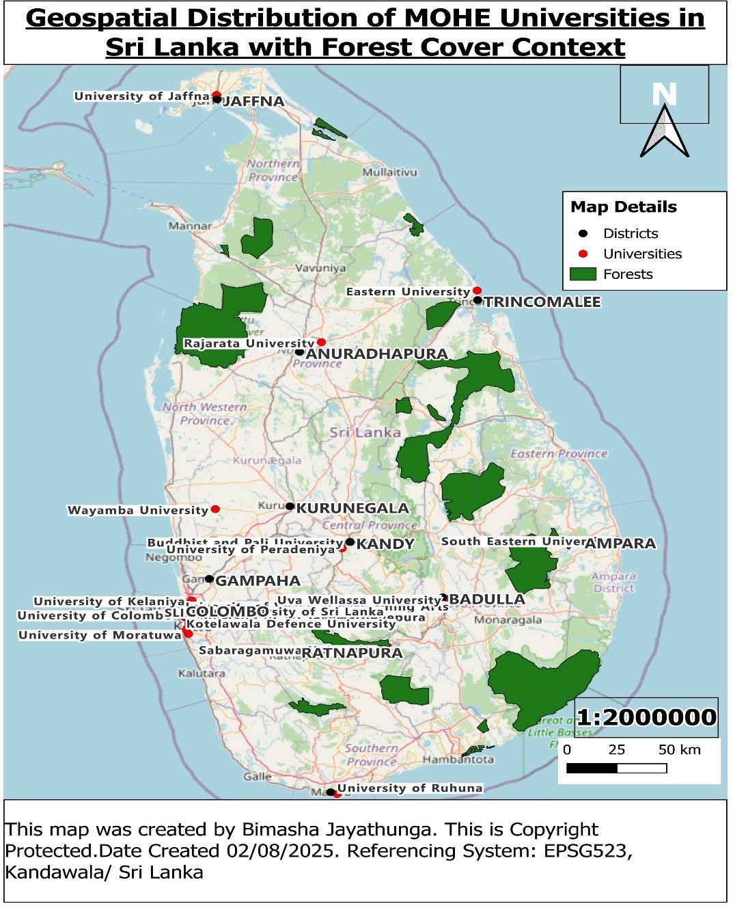

The forest cover significantly influences the environmental, academic, and institutional landscape of MOHE universities in Sri Lanka. Environmentally, universities near large forest area have opportunities for biodiversity conservation, climate research and sustainable resource management. Academically, institutions such as Rajarata, Uwa Welassa, Eastern and sabaragamuwa universities benefit from proximity to forest for forestry, agriculture and environmental science programs. University wise, urban universities like Colombo, moratuwa and kaleniya are distanced from forest areas and focus more on engineering and technology. The pros include research opportunities, environmental awareness and potential for eco-tourism partnerships, while cons involve possible conflicts with conservation zones, infrastructure challenges and restrictions on campus expansion in heavily forested regions.

Base map 4- Railway Infrastructure
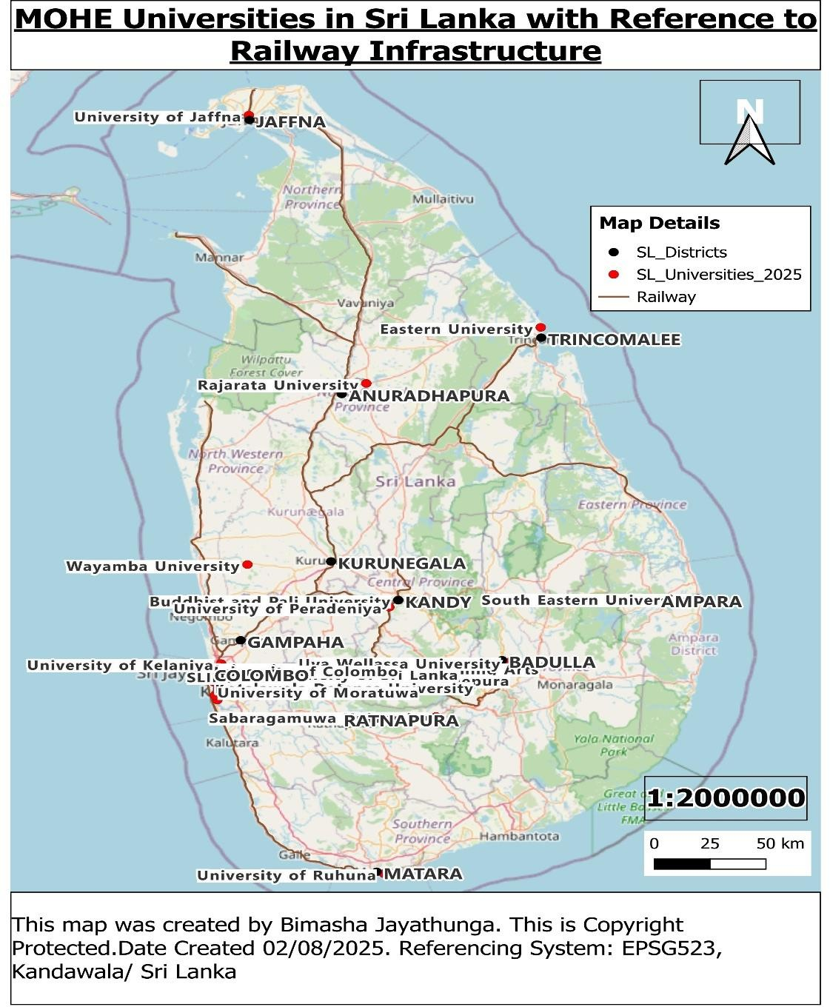
The railway infrastructure significantly shapes the social, economic and accessibility landscape of MOHE universities in Sri Lanka. Socially, universities located near major railways lines benefit from enhanced connectivity, enabling easier commuting for students and staff from diverse regions. Economically, institutions such as UOP, UOM and UOC gain advantage through improved access to urban centers and industrial hubs, facilitating partnership and internship opportunities. University wise, those with limited railway connectivity, like universities in remote or less accessible districts, face challenges in attracting students and resources. The pros include increased mobility, regional development and cost effective transport options, while cons involve dependency on railway schedules, maintenance issues and possible noise pollution affecting campus environments.

Task (E)
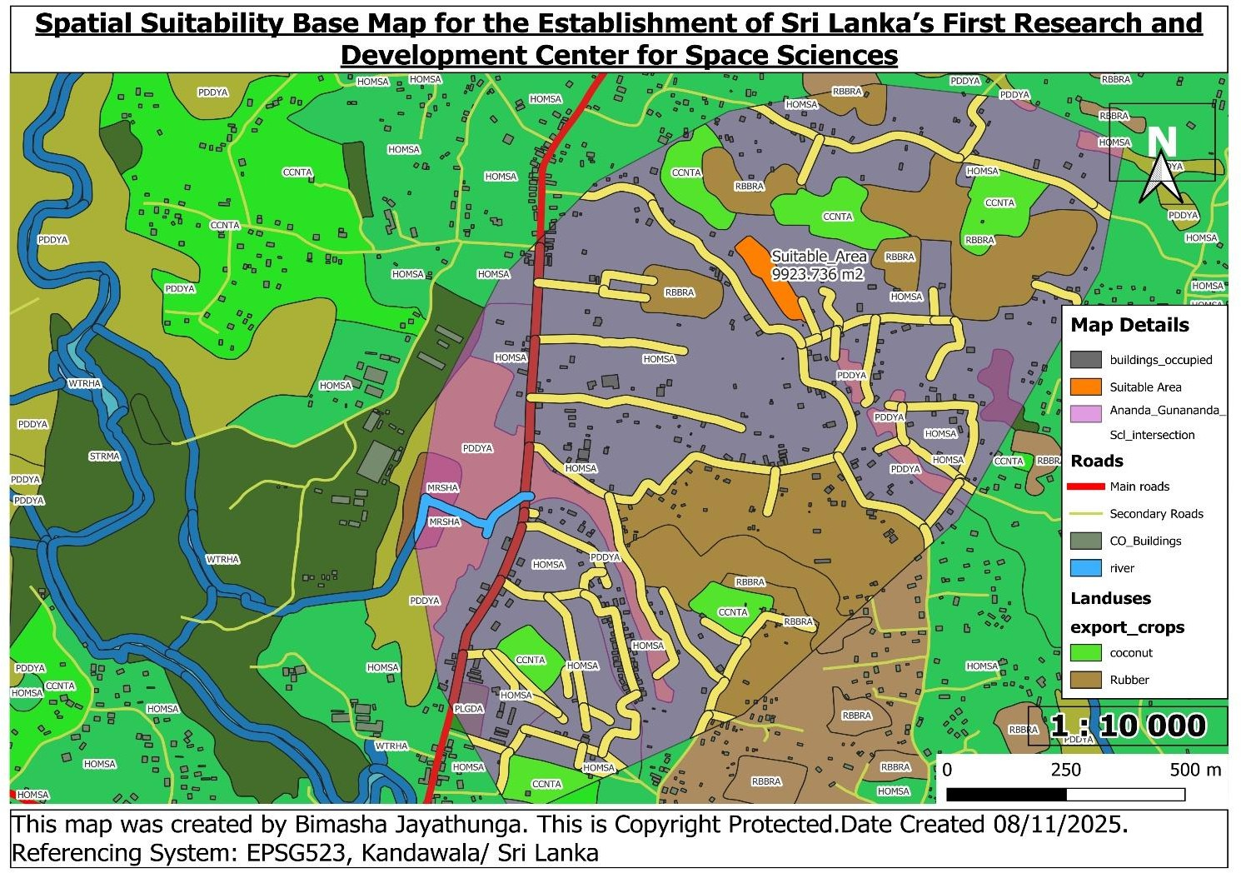
Base Map

Critical discussion of the feasibility of the decision of establishing the aforesaid Research Center in the identified area

Sri Lanks’s panning to establish its first ever Research and Development Center for Space Sciences, aiming to promote scientific innovation and technological advancement in the country. Selecting an appropriate site is crucial to ensure that the center operates efficiently while minimizing environmental and social impacts. The site selection process considered multiple factors including proximity to educational institutions, soil suitability, land use types and avoidance of traditional export crop areas.
The establishment of Sri Lanka’s first ever Research and Development Center for Space Sciences is feasible in the identified area, primarily due to the presence of scrub land(SCRBA), which has been selected as the optimal site. Scrub land is characterized by sparse, low-density vegetation and minimal active agricultural use, representing degraded or transitional land with lower ecological and economic value. Developing on scrub land would minimize disruption to natural habitats and

biodiversity. Additionally, scrub land is easier and more cost effective to clear and prepare for construction compared to dense forests or cultivated agricultural lands, facilitating efficient development.

The study area covers approximately 8,999,360m² (8.99km²), offering a comprehensive spatial context for the project. Within the defined suitability zone, there are currently 452 buildings occupying around 39,008.28m². This indicates moderate development with existing infrastructure, but it also reduces the available land for new construction. After applying soil and land use criteria, the strictly suitable land area is about 9,923.736m². Considering building footprints and buffer zones, the total available land expands to roughly 1,487,189.02m², providing sufficient space for the research center and potential future expansions.

Export crop areas such as coconut(CCNTA), cinnamon(CNMNA) and rubber(RBBRA) have been excluded from consideration because they are vital to Sri Lanka’s economy. These plantations represent long term agricultural investments that contribute significantly to local livelihoods and export earnings. Conversation of these lands would disrupt agricultural productivity and risk economic losses and social conflicts, making their exclusion crucial for sustainable land management and social harmony.
While homestead and garden areas (HOMSA) are often preferred due to their proximity to existing infrastructure and communities, they present challenges such as potential displacement of residents and distribution of established settlements. Developing in HOMSA areas would require careful social panning, compensation and possible resettlement, complicating the project timeline and feasibility. Moreover, other land uses such as cemeteries (CMTYA), marshes (MRSHA), minor streams (STRMA), water holes (WTRHL), paddy fields (PDDYA), and playgrounds (PLGDA) have been excluded because of their environmental sensitivity, cultural importance and community value. These zones support biodiversity, water management, food security and recreation and development on these lands would cause unacceptable ecological and social impacts.

In conclusion, considering ecological preservation, socio-economic factors and available land resources, the identified scrub land area within the suitability zone provides a responsible and visible site for establishing the Research and development center, balancing the needs of development with environmental and community stewardship.

References
mohe.gov, 2025. The Higher Education Sector of Ministry of Education. [Online]
Available at: https://mohe.gov.lk/index.php?lang=en [Accessed 13 August 2025].

